EXP NO 1: CREATE A SIMPLE CLOUD SOFTWARE APPLICATION AND PROVIDE IT AS A SERVICE USING ANY CLOUD SERVICE PROVIDER TODEMONSTRATE SOFTWARE AS A SERVICE (SAAS).

THE SOFTWARE HASE BEEN CREATED.

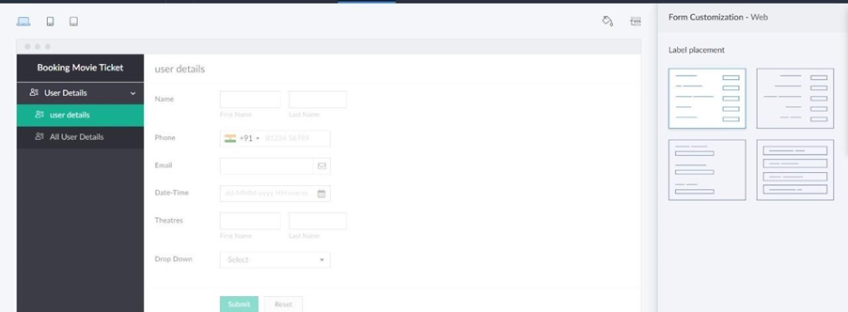

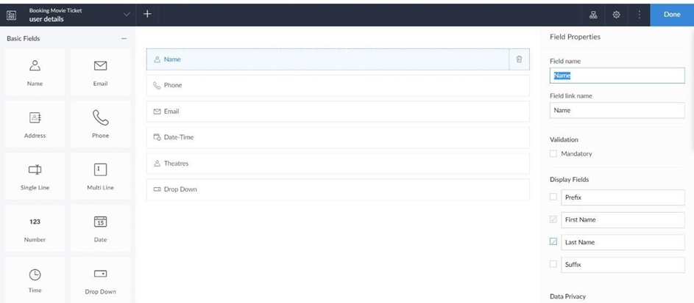

EXP NO 2: CREATE A SIMPLE CLOUD SOFTWARE APPLICATION FOR FLIGHT RESERVATION SYSTEM USING ANY CLOUD SERVICE PROVIDER TO DEMONSTRATE SAAS.

THE SOFTWARE HASE BEEN CREATED.



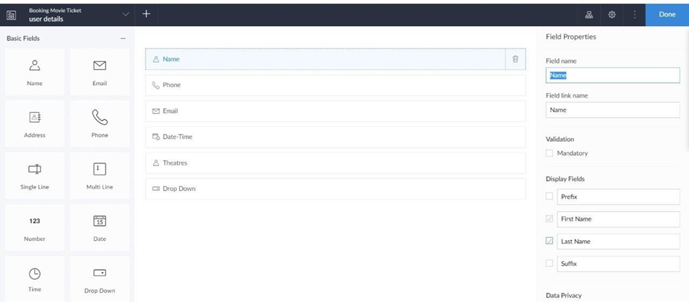

EXP NO 3: CREATE A SIMPLE CLOUD SOFTWARE APPLICATION FOR PROPERTY BUYING & RENTAL PROCESS (IN CHENNAI CITY) USING ANY CLOUD SERVICE PROVIDER TO DEMONSTRATE SAAS.

THE SOFTWARE HASE BEEN CREATED.





EXP NO 4: CREATE A SIMPLE CLOUD SOFTWARE APPLICATION FOR CAR BOOKING RESERVATION SYSTEM USING ANY CLOUD SERVICE PROVIDER TO DEMONSTRATE SAAS.

THE SOFTWARE HASE BEEN CREATED.





EXP NO 5: CREATE A SIMPLE CLOUD SOFTWARE APPLICATION FOR LIBRARY BOOK RESERVATION SYSTEM FOR SIMATS LIBRARY USING ANY CLOUD SERVICE PROVIDER TO DEMONSTRATE SAAS.

THE SOFTWARE HASE BEEN CREATED.





EXP NO 6: CREATE A SIMPLE CLOUD SOFTWARE APPLICATION FOR PRODUCT SELLING USING ANY CLOUD SERVICE PROVIDER TO DEMONSTRATE SAAS.

THE SOFTWARE HASE BEEN CREATED.





EXP NO 7: DEMONSTRATE VIRTUALIZATION BY INSTALLING TYPE-2 HYPERVISOR IN YOUR DEVICE, CREATE AND CONFIGURE VM IMAGE WITH A HOST OPERATING SYSTEM (EITHER WINDOWS/LINUX).

CREATED TINYOS VIRTUAL MACHINE

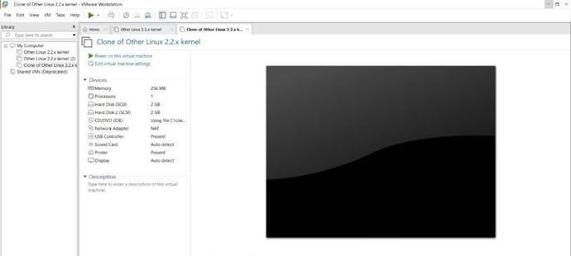

LAUNCH THE VM

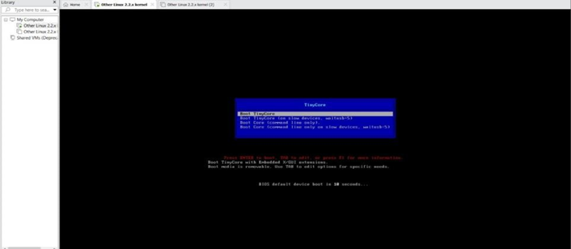

EXPNO 8: CREATE A VIRTUAL MACHINE WITH 1 CPU, 2GB RAM AND 15GB STORAGE DISK USING A TYPE 2 VIRTUALIZATION SOFTWARE.

CREATED TINYOS VIRTUAL MACHINE



EXP 9: CREATE A VIRTUAL HARD DISK AND ALLOCATE THE STORAGEUSING VM WARE WORKSTATION.

GIVE NAME AND CLICK THE FINISH

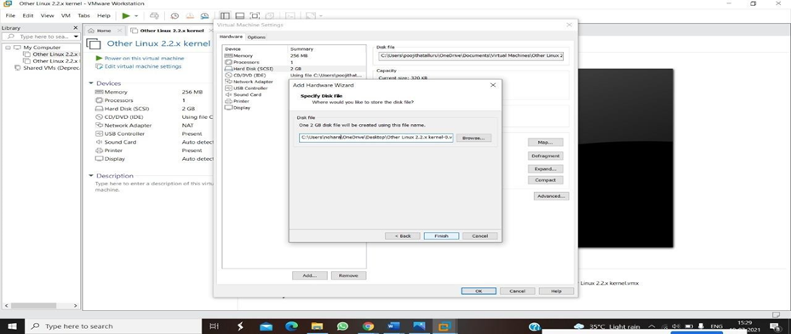

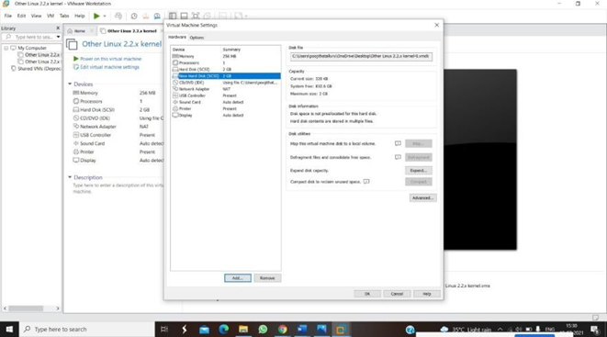

EXPNO 10: CREATE A SNAPSHOT OF A VM AND TEST IT BY LOADING THE PREVIOUS VERSION/CLONED VM

SNAPSHOT IS BEING DONE

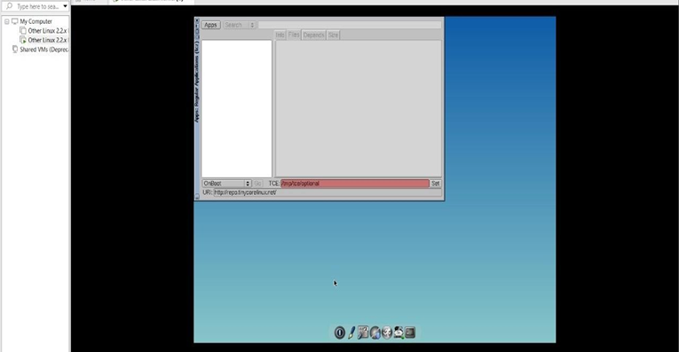

EXPNO 11: CREATE A CLONING OF A VM AND TEST IT BY LOADING THE PREVIOUS VERSION/CLONED VM.

AFTER CLONE AGAIN OR VM IS OPENED

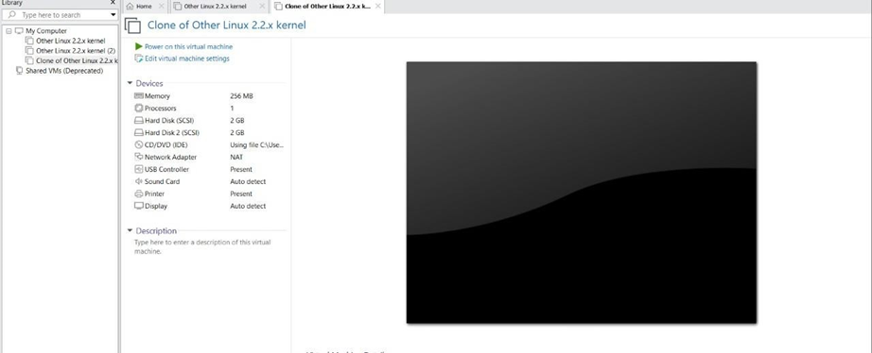

EXP 12: CHANGE HARDWARE COMPATIBILITY OF A VM (EITHER BY CLONE/CREATE NEW ONE) WHICH IS ALREADY CREATED AND CONFIGURED.

GIVE NAME AND CLICK THE FINISH





EXP13. DEMONSTRATE INFRASTRUCTURE AS A SERVICE (IAAS) BY CREATING A VIRTUAL MACHINE USING A PUBLIC CLOUD SERVICE PROVIDER (AZURE), CONFIGURE WITH REQUIRED MEMORY AND CPU.

CREATED A NEW WINDOWS VIRTUAL MACHINE.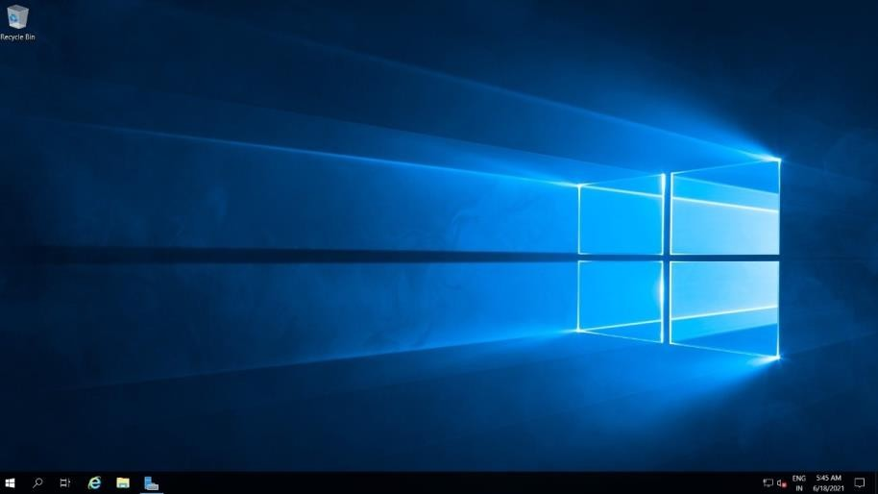

EXP 17. DEMONSTRATE INFRASTRUCTURE AS A SERVICE(IAAS) BY CREATING AVIRTUAL MACHINE USING A PUBLIC CLOUD SERVICE PROVIDER(AZURE/GCP/AWS) CONFIGURE WITH MINIMUM CPU, RAM ANDSTORAGE AND LAUNCH THE VM IMAGE.

CREATED A NEW WINDOWS VIRTUAL MACHINE.

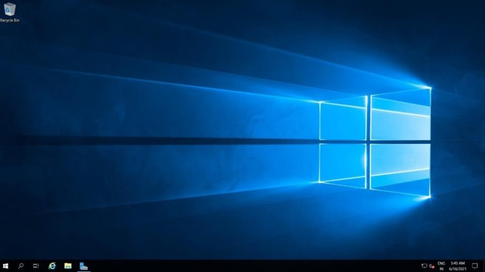

EXP15.CREATE A SIMPLE WEB SITE USING ANY PUBLIC CLOUD SERVICE PROVIDER (AZURE/GCP/AWS) AND CHECK THE PUBLIC ACCESSIBILITY OFTHE STORED FILE TO DEMONSTRATE STORAGE AS A SERVICE

THIS IS OUR WEBAPP SERVICE.

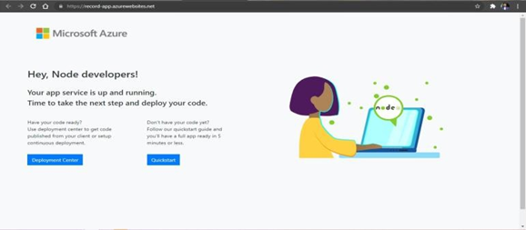

EXP19.CREATE A STORAGE SERVICE USING ANY PUBLIC CLOUD SERVICE PROVIDER (AZURE/GCP/AWS) AND CHECK THE PUBLIC ACCESSIBILITY OFTHE STORED FILE TO DEMONSTRATE STORAGE AS A SERVICE.

AND AGAIN, RETURN TO STATIC WEBSITE AND OPEN THE PRIMARYLINK AND YOUR WEB PAGE IS CREATED

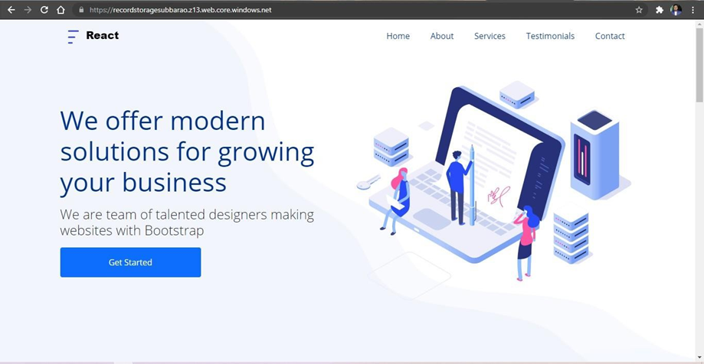

EXP20.CREATE A SQL STORAGE SERVICE AND PERFORM A BASIC QUERY USINGANY PUBLIC CLOUD SERVICE PROVIDER (AZURE/GCP/AWS) TO DEMONSTRATE DATABASE AS A SERVICE (DAAS)

AND OUR OUTPUT IS READY.

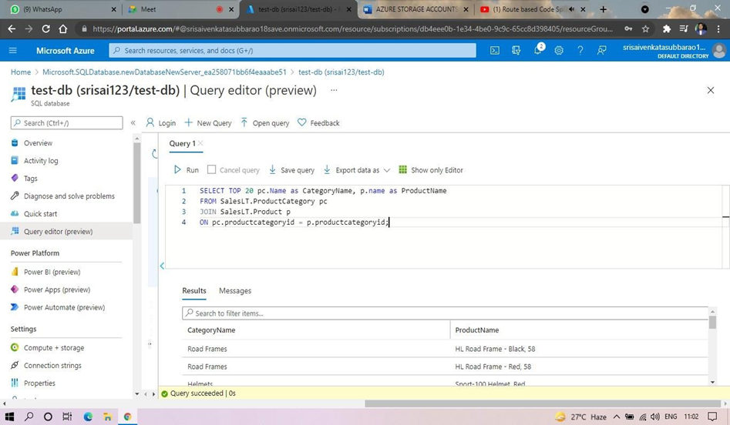

EXP. 22: PERFORM THE BASIC CONFIGURATION SETUP FOR INSTALLINGHADOOP 2.X LIKE CREATING THE HDUSER AND SSH LOCALHOST

OUTPUT:  
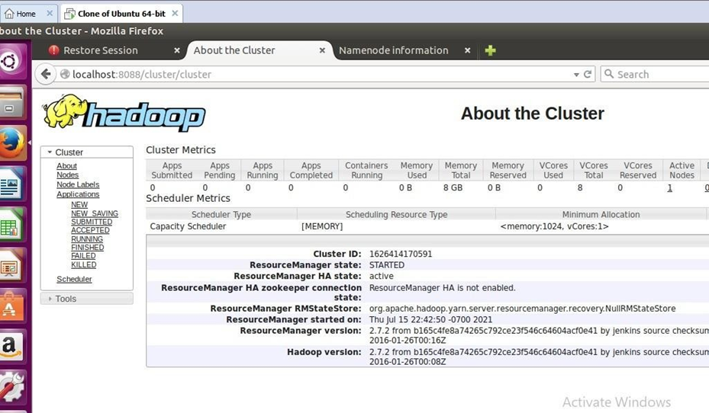

EXP. 23: INSTALL HADOOP 2.X AND CONFIGURE THE NAME NODE AND DATANODE

OUTPUT:

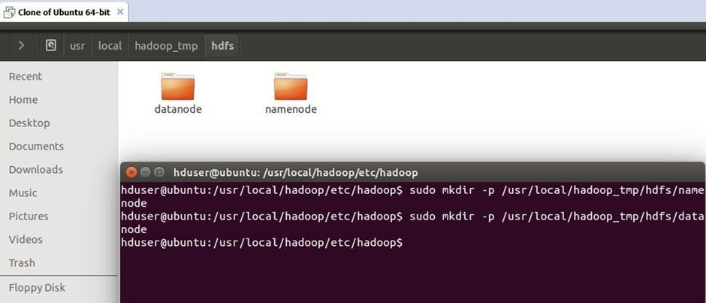

EXP. 24: LAUNCH THE HADOOP 2.X AND PERFORM MAPREDUCE PROGRAMFOR A WORD COUNT PROBLEM

OUTPUT:

